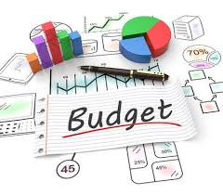
SaveNScore™

User Guide

© May 2019 CS451, Inc.

Table of Contents

Introduction 1
Getting Started 2
System Requirements 2
Quick Start 2
Launching the Application 3
Using the Navigation Bar 5
Managing Goals 6
Entering Goal Information 6
Completing Goals 7
Viewing Account Data 8
Viewing a List of Accounts 8
Viewing Account Details 9
Viewing Goals Associated with an Account 11
Viewing Achievements 12
Glossary 13
Account 13
Achievement 13
Category 13
Goal 13
Transaction 13

Introduction

Budgeting is the process of creating a plan of how to spend your money. Tracking how closely you follow this plan is just as important as creating a plan in the first place. The only way to make objective choices about your budget is to analyze the actual data.

SaveNScore doesn’t just track your transactions. You could do that with a paper ledger.

With SaveNScore you can also:
- View account details
- Set budgetary goals and track progress
- Track account balance history
- View spending by category

The SaveNScore application maintains historical data which can help you analyze your current and past expenditures. With this data, you can determine set goals, such as for saving a certain amount of money each month or reducing expenditures in certain categories.

SaveNScore does this all with an easy-to-use interface available in any web browser.

Getting Started

System Requirements

Any internet-enabled device using a modern web browser, such as Chrome, Internet Explorer, Firefox, or Safari.

Quick Start

- In your web browser, navigate to www.SaveNScore.com
- Click the “Register” link in the upper right to go to create a user profile.
- Enter your profile information, then click “Register”
- If your registration was successful, your username will be displayed in the upper right of the page.
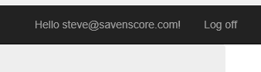
- Use the Navigation Bar to view or manage Goals, view Accounts, or track Achievements.

Launching the Application

To launch the application from any modern web browser, enter www.SaveNScore.com.

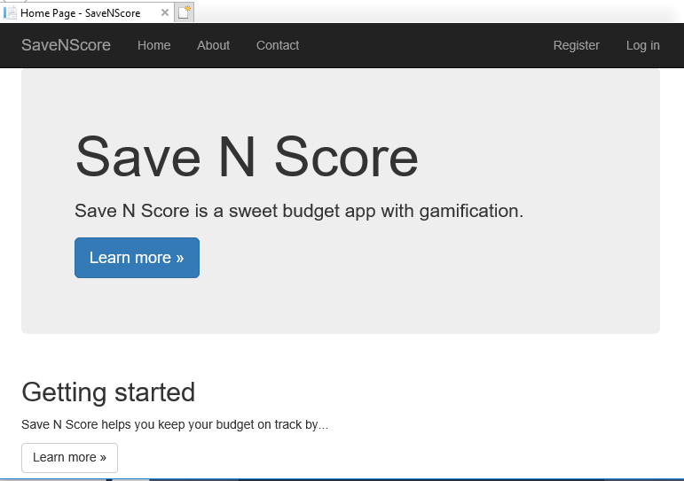

Then choose the Register option to register a new profile or Login to login to an existing profile.
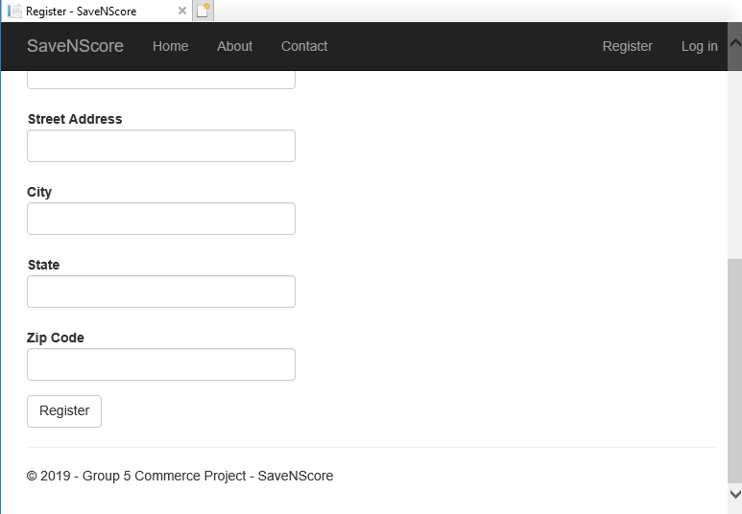

Using the Navigation Bar

Choose one of the following options from the main menu:

Home
Return to the Home page for useful links on managing budgets.

About
Learn more about the SaveNScore team.

Contact
Contact the SaveNScore team.

Goals
View, Create, or Manage budgetary goals.

Account
View Accounts linked to your profile.

Achievements
View past Achievements and track progress toward new ones.



Managing Goals

To view or manage goals, choose Goals from the Navigation Bar.

Entering Goal Information

To enter a new goal:

- Choose <Create New> on the Goals page.
- Choose SaveByDate or Recurring from the Goal Type dropdown list.
- Select the time period of the goal from the available options.
- Enter the goal amount, starting and completion dates, and a description of the goal
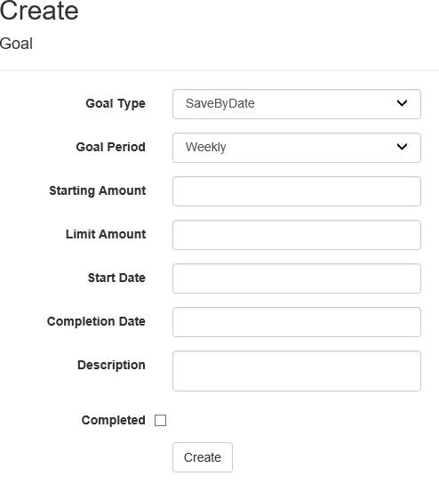

- Once desired Goal information has been entered, choose Create.

Completing Goals

Existing Goals are listed on the Goals page. To mark goal as complete, click the checkbox in the Complete column of the goals entry.

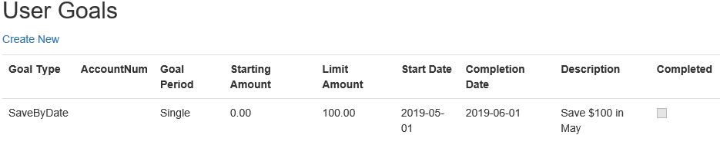

Viewing Account Data

Viewing a list of accounts

To view accounts linked to your user profile, choose Accounts in the Navigation Bar.

A list of accounts will be displayed with account number, account type, and current balance.

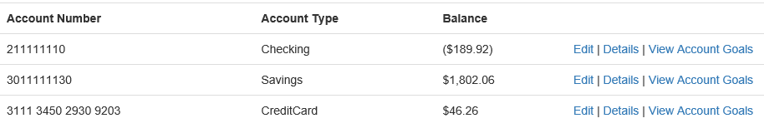

Viewing Account Details

To view account details, choose the <Details> link in that account’s entry in the Accounts list.

Account Balance History:
Balance History is displayed as a step-line chart.
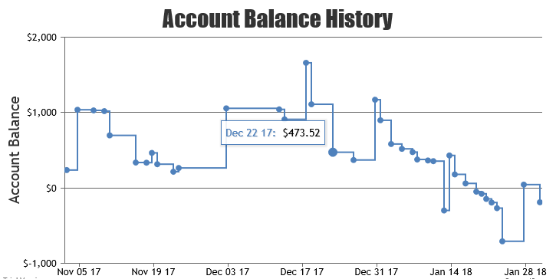.

Spending By Category:
Spending by Category is displayed as a pie chart. This chart can be saved as an image file.
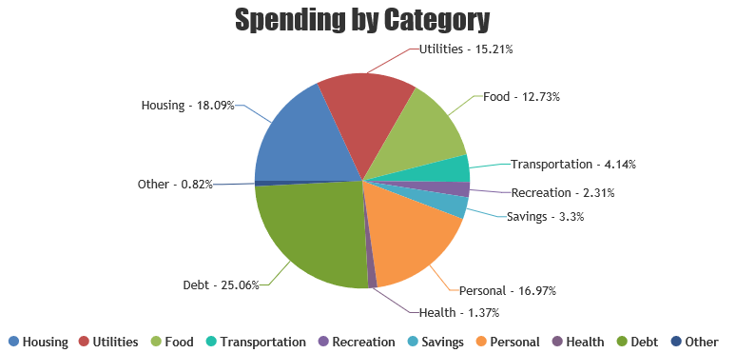

Transaction List:
Details of all account transactions are listed in a table with the most recent transactions listed first.

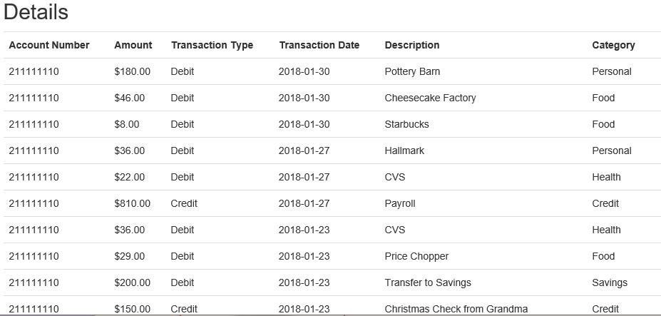

Viewing Goals Associated with an Account

To view goals associated with an account, choose the <view account goals> link in that account’s entry in the Accounts list.

Goals associated with this account will be displayed in a table. You can also create new goals using the links on this page.

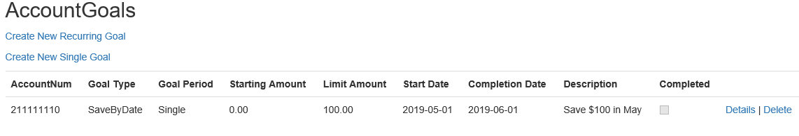

Viewing Achievements

To view achievements linked to your user profile, choose Achievements in the Navigation Bar.

A list of achievements will be displayed with completion status, description, and conditions.

Completion Status
This indicates whether the conditions of an achievement have been met, and updates automatically will the achievement conditions have been satisfied.

Description
Edit or delete a single tank of fuel for a vehicle

Count To Unlock
The number of conditions left to meet in order to unlock an achievement.

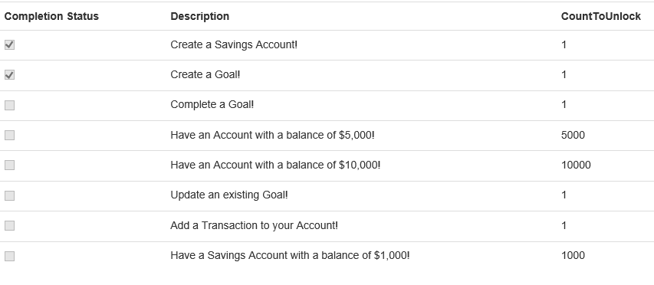

Glossary

Account
User financial accounts associated with a profile. These may be checking, savings, or credit card accounts.

Achievement
An Random access memory; main computer storage available for programs and data.

Category
The type of spending for a transaction. Categories include: Housing, Utilities, Food, Transportation, Recreation, Savings, Personal, Health, Debt, and Other. All credits on an account have the category Credit.

Goal
A user-generated time-bound budgetary goal. Goals are associated with accounts, and may be single or recurring.

Transaction
A credit or debit on an account.

